EE5351_DIGITAL VIDEO CODING

JPEG_LOSSLESS ASSIGNMENT

NAME: PAVAI ARCHIMEDES

ST ID: 1001233996

OMEGA SERVER:

ENCODING:

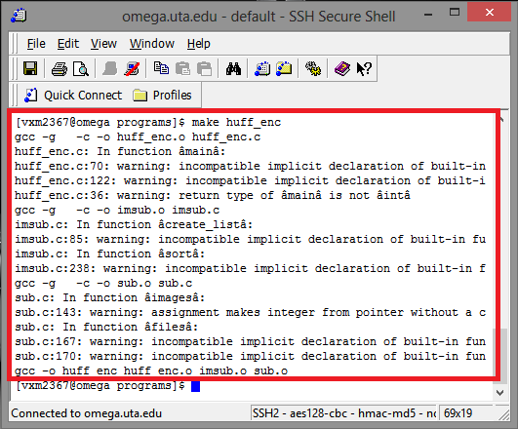

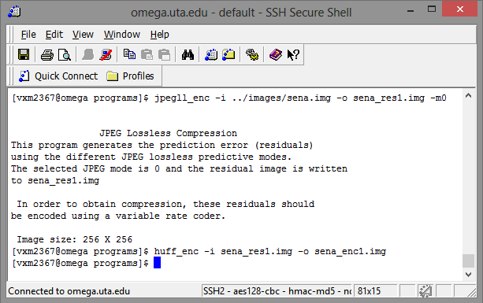

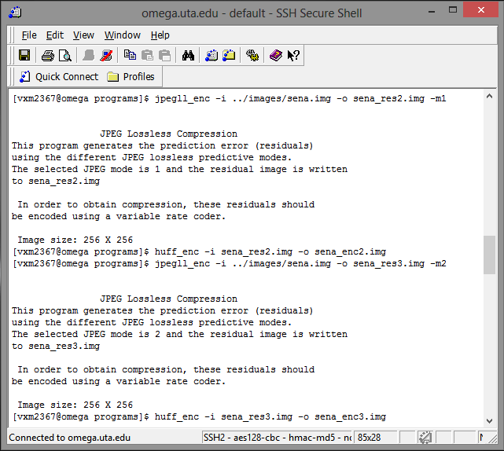

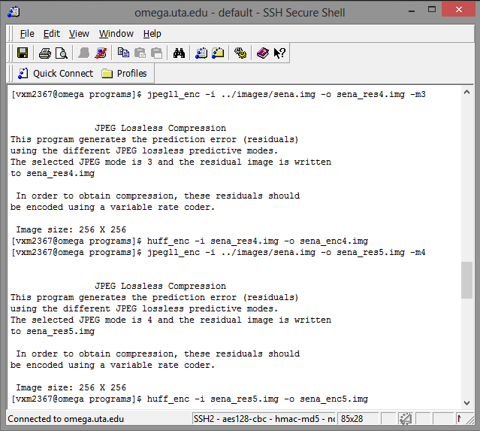

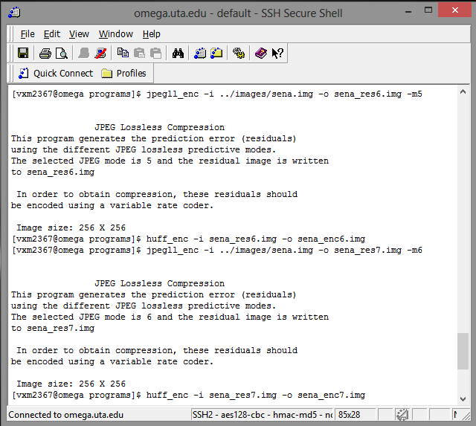

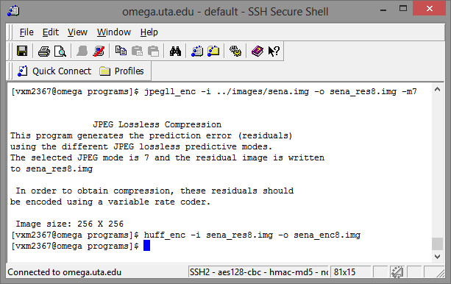

This process is done similarly for all the other three images i.e., sensin, earth and Omaha. The respective outputs image sizes are listed below in bytes.

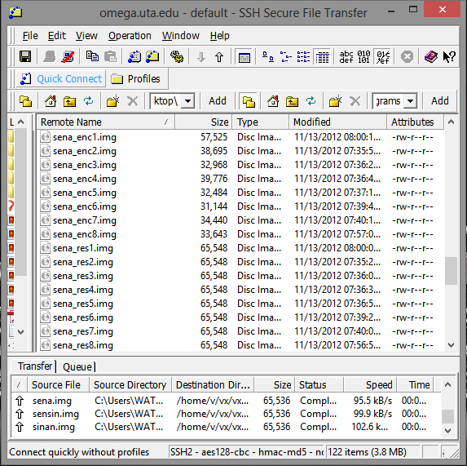

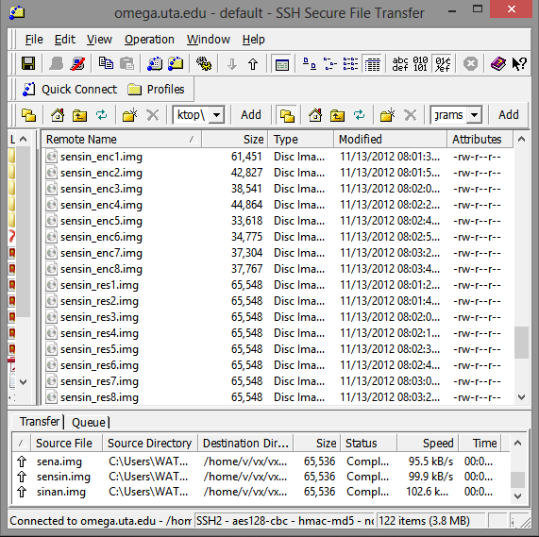

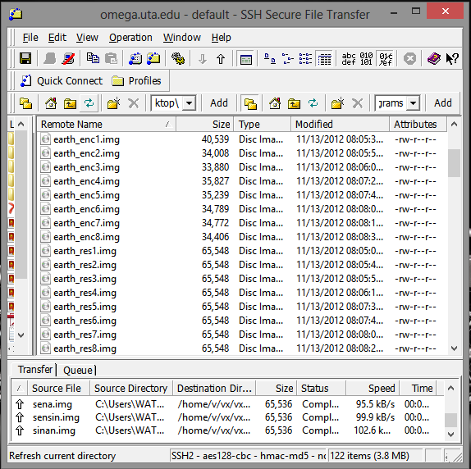

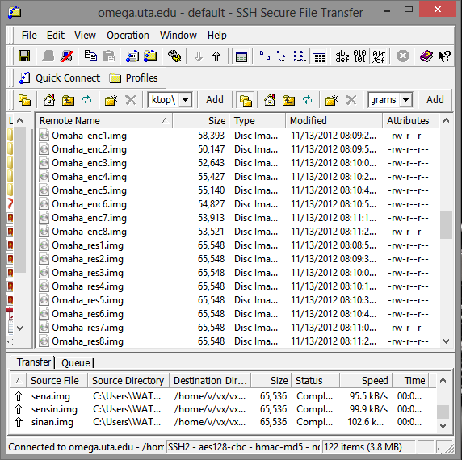

OBSERVATION:

|  |  |  |  |  |  |  |  |  |
| --- | --- | --- | --- | --- | --- | --- | --- | --- |
| IMAGES | Jpeg 0 | Jpeg1 | Jpeg2 | Jpeg3 | Jpeg4 | Jpeg5 | Jpeg6 | Jpeg7 |
| SENA | 57525 | 38695 | 32968 | 39776 | 32484 | 31144 | 34440 | 33643 |
| SENSIN | 61451 | 42827 | 38541 | 44864 | 33618 | 34775 | 37304 | 37767 |
| EARTH | 40539 | 34008 | 33880 | 35827 | 35239 | 34789 | 34772 | 34406 |
| OMAHA | 58393 | 50147 | 52643 | 55427 | 55140 | 54827 | 53913 | 53521 |

* COMPRESSION RATIO = ORIGINAL IMAGE SIZE/COMPRESSED IMAGE SIZE.
* SIZE OF THE ORIGINAL IMAGE = 65536 Bytes

|  |  |  |  |  |  |  |  |  |
| --- | --- | --- | --- | --- | --- | --- | --- | --- |
| IMAGES | Jpeg0 | Jpeg1 | Jpeg2 | Jpeg3 | Jpeg4 | Jpeg5 | Jpeg6 | Jpeg7 |
| SENA | 1.1393 | 1.6937 | 1.9879 | 1.6476 | 2.0175 | 2.1043 | 1.9029 | 1.9480 |
| SENSIN | 1.0665 | 1.5302 | 1.7004 | 1.4608 | 1.9494 | 1.8846 | 1.7568 | 1.7353 |
| EARTH | 1.6166 | 1.9271 | 1.9344 | 1.8292 | 1.8598 | 1.8838 | 1.8847 | 1.9048 |
| OMAHA | 1.1223 | 1.3069 | 1.2449 | 1.1824 | 1.1885 | 1.1953 | 1.2156 | 1.2245 |

DECODING:

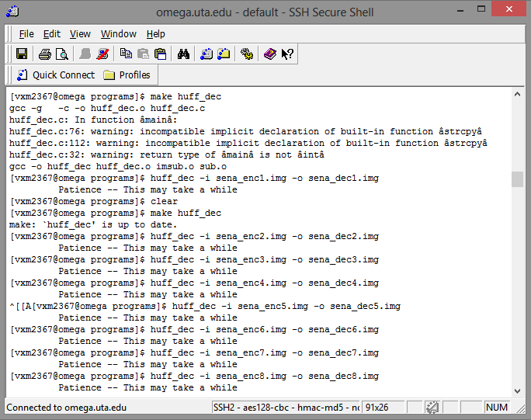

This process is done similarly for all the other three images i.e., sensin, earth and Omaha. The respective outputs image sizes are listed below in bytes.

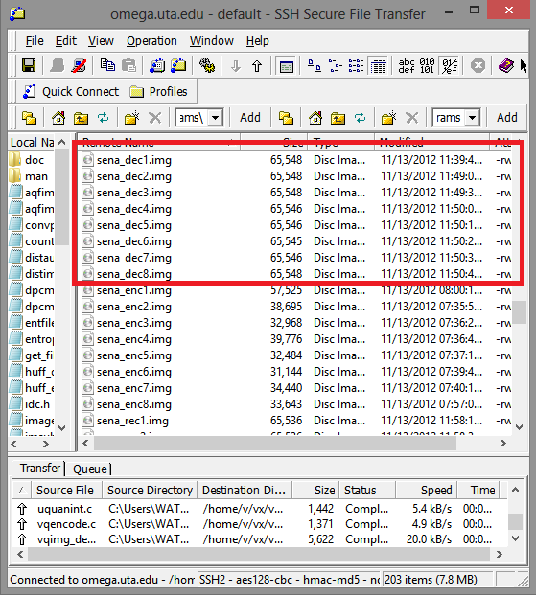

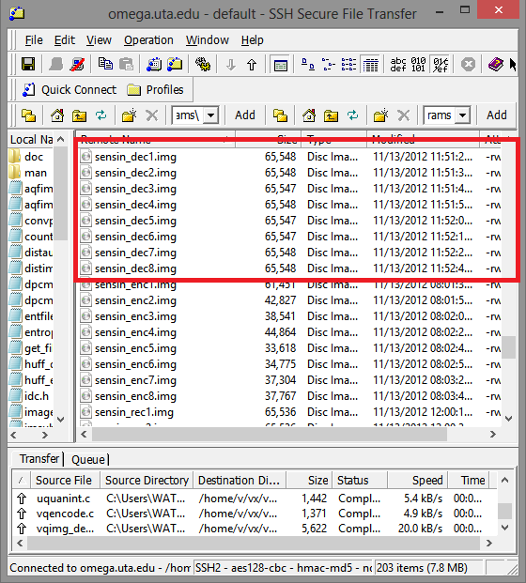

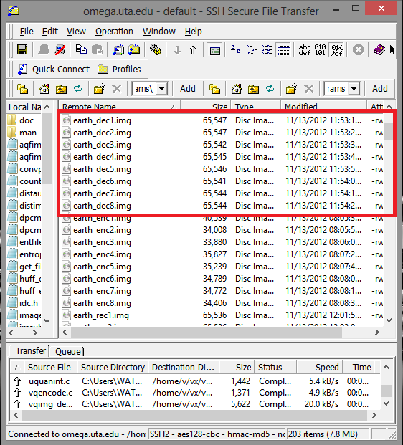

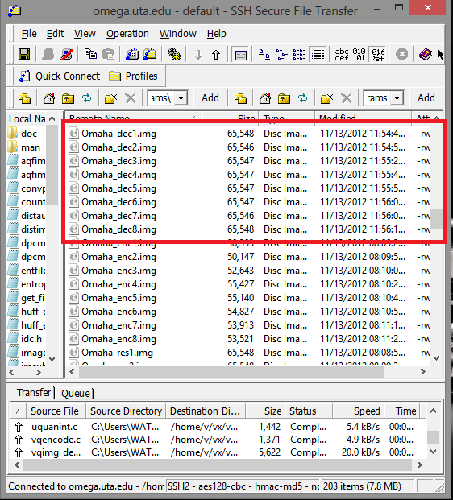

RECONSTRUCTED IMAGE:

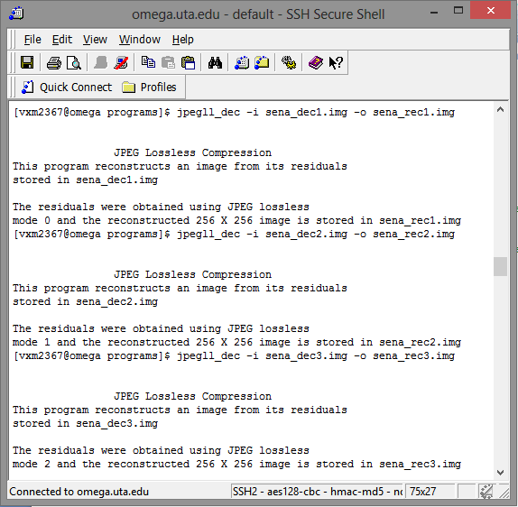

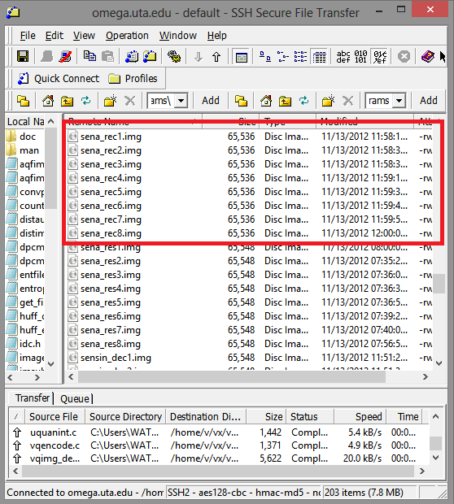

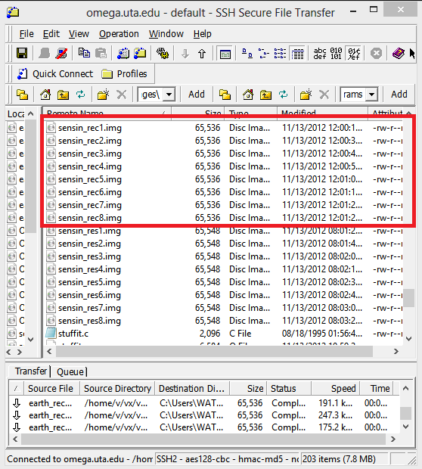

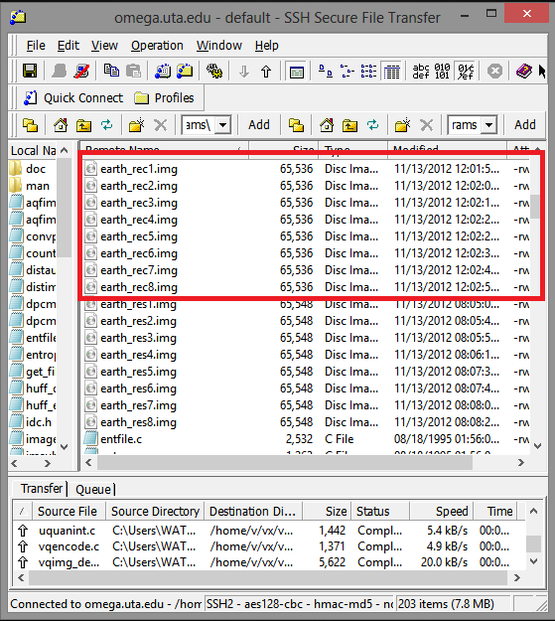

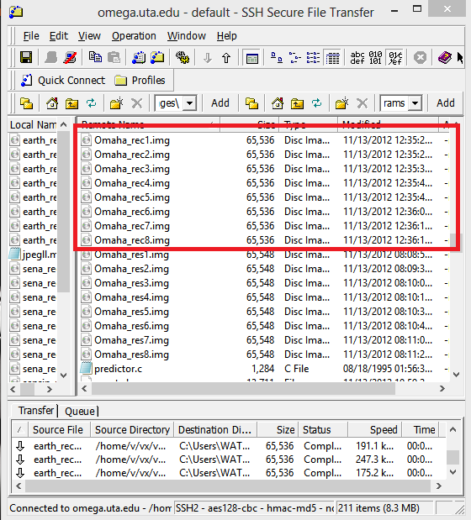

PROGRAM:

Clc;

close all;

clear all;

image={'sena_rec1.img','sena_rec2.img','sena_rec3.img','sena_rec4.img',

'sena_rec5.img','sena_rec6.img','sena_rec7.img','sena_rec8.img'};

% RENAMING THE RECONSTRUCTED IMAGES BY THEIR MODES OF PREDICTION

name={'REC M0','REC M1','REC M2','REC M3',

'REC M4','REC M5','REC M6','REC M7'};

% SHOWING UP THE RECONSTRUCTED IMAGES

for i=1:8

fid = fopen(image{i});

Image = fread(fid);

Image = reshape(Image,[256 256]);

Image = Image';

subplot(3,3,i);

imshow(uint8(Image));

title(name{i});

end

RECONSTRUCTED IMAGE: 





